
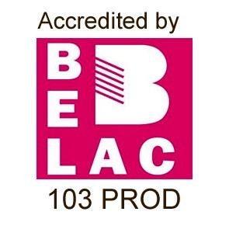



INTEGRA
www.tuv-nord-integra.com
Statiestraat 164
,
2600 Berchem, Belgium
Herbafrost nv
Industriepark 19 Zone A2, 2235 Hulshout, Belgium
Company Number: 0469917884
Client Number: 5324
Herewith the certification body TÜV NORD Integra, being an ISO/IEC 17065 accredited certification body for IFS certification and having signed an agreement with IFS
Management GmbH, confirms that the processing activities of the company/site mentioned below for the scope mentioned below meet the requirements set out in the IFS
Food Version 7, OCTOBER 2020 and other associated normative documents.
Certificate
IFS Food
Certified site
Hulshout: Industriepark 19 Zone A2, 2235 Hulshout, Belgium
COID: 15409 - GLN 5425007720006 - AER/ANT/007631 - Higher level 99,34 %
Scope
Processing (washing, freezing, cutting, portioning) of frozen herbs (IQF, drops). Packaging of frozen herbs, spices and vegetables in
plastic retail, food service and industrial packaging.
Exclusion: None
Product scopes and technology scopes
5
. Fruit and vegetables - DF
Besides own production, the company has partly outsourced processes.
The company has own broker activities which are not certified against a GFSI recognized scheme.
Certificate ID: 146536
Certificate issue date: 4/09/2023
Date of expiration of the certificate: 16/10/2024
Assessment date: 9/08/2023
Next assessment should be conducted in a period of 10 weeks (announced) or 18 weeks (unannounced) before 05/09/2024
Assessment program: announced
Guy Buysse, General Manager
Last assessment conducted unannounced: 24/08/2022
Unified Certificate v.2 EN

