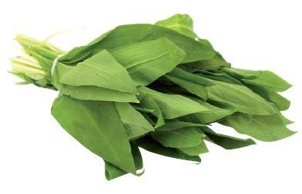
IQF frozen

CONVENTIONAL
BEAR’S GARLIC
Allium ursinum

English Nederlands Français Deutsch Italiano Español Suomi
100% 100% 100% 100% 100% 100% 100%
conventional conventionele Ail des ours konventioneller Aglio orsino Ajo de oso Villi valkosipuli Bear’s garlic Daslook conventionel Bärlauch convenzionale convencional tavanomainen

Country of origin | Rumania, Bulgaria, Germany
Customs tariff n° | 0710 8095
Physical criteria | Colour Green  Taste Typical for the product, no off-taste  Odour Typical for the product, no off-smell  Texture Individually Quick Frozen (IQF) pieces  Dry matter 6 to 13%
Produced for  HACCP & legislation | Herbafrost NV  Part II. General Data Sheet (Doc nr. EPS.II.01)  Fresh Frozen Herbs – CONVENTIONAL

Nutritional Information
 | Energy value (kJ) 79 Energy value (kcal) 19
Fat (g)  Of which saturated fatty acids (g)  Of which mono-unsaturated fatty acids (g) Of which poly-unsaturated fatty acids (g) | 0.30 Carbohydrate (g)  0.10 Of which Sugars (g)  0 Of which polyols (g)  0 Of which starch | 3  2.90  0  0
Protein (g)  Dietry Fibre (g) | Sodium Na (mg)  1.00  Salt NaCl (mg)  2.20  Cholesterol (mg) | 16  40  0
Average content per 100g finished product (Source: literature)

 | Allergen information
SUBSTANCES | DERIVATIVES | Presence in the product | Presence in the factory
1. Cereals containing gluten | (Wheat, rye, barley, oats, spelt, kamut or their hybrid strains) and products based on these cereals | No | No
2. Crustaceans | Products based on crustaceans | No | No
3. Egg | Egg-based products | No | No
4. Fish | Fish-based products | No | No
5. Peanuts | Peanut-based products | No | No
6. Soy | Soy-based products | No | No
7. Cow’s milk | Milk-based products (including lactose) | No | No
8. Nuts | Almonds, hazelnuts, walnuts, cashew nuts, pecan nuts, brazil nuts, pistachio nuts, macadamia nuts and queensland nuts, and products based on these nuts | No | No
9. Celery | Celery-based products | No | No
10. Mustard | Mustard-based products | No | No
11. Sesame | Products based on sesame seeds | No | No
12. Sulpher dioxide and sulphites | Sulphur dioxide and sulphites (E220 – E228) at concentrations of more than 10mg/kg or 10mg/litre, expressed as SO₂ | No | No
13. Lupin | Lupin-based products | No | No
14. Molluscs | Mollusc-based products | No | No

Lactose | No | No
Cocoa | No | No
Glutamate (E620 - E625) | No | No
Components of chicken, beef, pork, sheep or other animals | No | No
Coriander | No | No
Corn / Maize | No | No
Legumes | No | No
Carrot | No | No

 |  | Available packaging - B2B
1 x 10 kg |  | 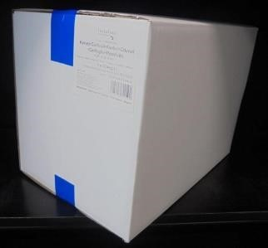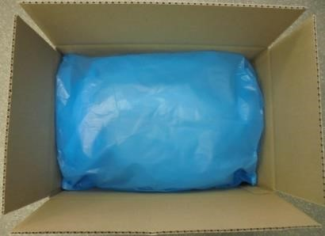  White box Blue PE food grade inner bag  Sealed with blue tape Folded over  Label in the right upper corner on the short side of the box
 | Palletization
Product name | IQF conventional  Bear’s garlic  1-3 mm 1x10kg |  | IQF conventional  Bear’s garlic  1-6 mm 1x10kg | IQF conventional  Bear’s garlic  1-8 mm 1x10kg
Product ID | C179IQF003II |  | C179IQF006II | C179IQF008II
EAN | 54 2500772 092 1 |  | 54 2500772 093 8 | 54 2500772 438 7
Palletization | Euro (Wood) |  | Euro (Wood) | Euro (Wood)
# Crt/pallet | 45 |  | 45 | 42
# Layers x Crt/layer | 5x9 |  | 5x9 | (4x9)+(1x6)
Pallet height | 170,5 cm |  | 201 cm | 201 cm
Carton | White box + Blue PE inner bag |  | White box + Blue PE inner bag | White box + Blue PE inner bag
# kg net/crt | 10 kg |  | 10 kg | 10 kg
LxWxH | 380x250x300 mm |  | 380x250x360 mm | 380x250x388 mm
Tara/crt | 468 g |  | 508 g | 528 g

Product name | IQF conventional Bear’s garlic  10-20 mm 1x10kg | IQF conventional Bear’s garlic  10-20 mm 1x5kg
Product ID | C179IQF020II | C179IQF020ID
EAN | 54 2500772 354 0 | 54 2500772 367 0
Palletization | Euro (Wood) | Euro (Wood)
# Total crt/pal | 42 | 90
# Layers x C/layer | (4x9)+(1x6) | 10x9
Pallet height | 189,8 cm | 220 cm
Carton | White box + Blue PE inner bag | White box + Blue PE inner bag
# kg net/carton | 10 kg | 5 kg
LxWxH | 380x250x360 mm | 380x250x210 mm
Tara/crt | 508 g | 338 g

Notes
Pallet height is including pallet.
Maximum pallet height is 210 cm.
Height of the carton can vary in function of the product volume.
Maximum carton height is 430 mm.
Tare weight of the boxes is average weight.
For private label and customized palletization, the 2 last digits of the article code differs. If applicable, conditions as contractually agreed.
For special cut sizes and package, please ask for our conditions and availability.

Product picture and description

1-3 mm  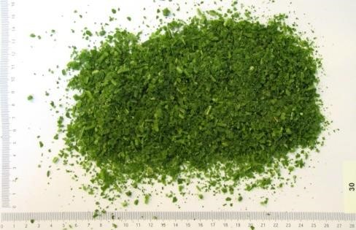  1mm to 3mm : min. 80%  > 3mm : max. 20% | 1-6 mm  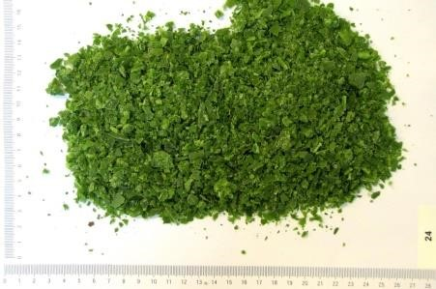  1mm to 6mm : mix. 80%  > 6mm : max. 20%
1-8 mm  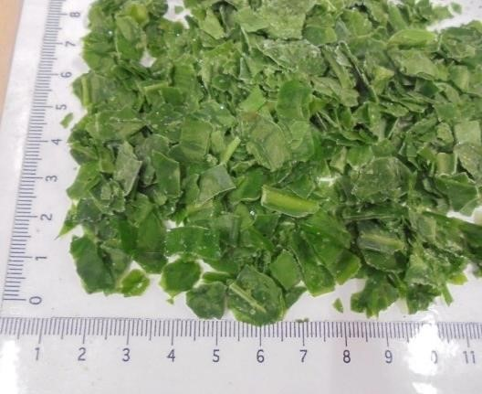  1mm to 8mm : min. 70%  <1mm : max: 20%  > 8mm : max. 10% | 10-20 mm  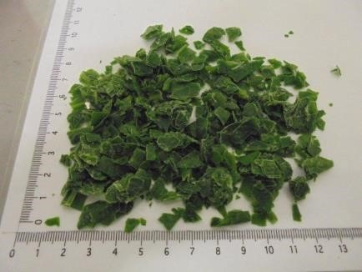  10mm to 20mm : min. 70%  <10mm : max: 20%  > 20mm : max. 10%
Defective parts
Max. 1% (weight) non-toxic vegetable material from the parent plant (flowers,...)
Max. 1% (weight) non-toxic vegetable material not from the parent plant
Max. 3% (weight) discoloured pieces
Max. 5% (weight) stems

Regulatory aspects
- The product is from non-GMO sources and not subject to GMO labelling.
- The product is not ionised.
- Heavy metals: In accordance with EU Regulation 2023/915 (and amendments)
- Pesticides: In accordance with EU Regulation 396/2005 (and amendments)
- Microbiology: In accordance with European Regulation 2073/2005 (and amendments

APPROVAL

To be completed by the customer
The hereafter named documents are part of this specification.
By signing this document, you agree with the content.
Section Doc. Nr. Doc. Name
Part I EPS.I.00 Supplier Information
Part II EPS.II.01 General product data: Fresh Frozen Herbs CONVENTIONAL
Date:

Name:
Function:

Signature & Company Stamp:

Please send the signed and approved product specification back to Herbafrost nv.
If we do not receive this signed product specification back within 7 working days, we consider the document as approved by your side.

In case of unexpected and exceptional circumstances, Herbafrost will try to meet the customers approved specification in the best possible way, but reserves the right to source products which could have different characteristics (eg. origin, weight, packaging, palletization, …). Herbafrost do guarantee that, whatever the situation may be, the food safety and authenticity of the product will never be compromised.

