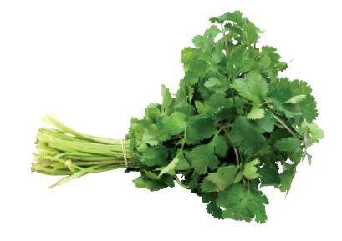

IQF

frozen

CONVENTIONAL

CORIANDER (cilantro)

Coriandrum sativum

English Nederlands Français Deutsch Italiano Español Suomi
100% 100% 100% 100% 100% 100% 100%
conventional conventionele Coriandre konventioneller Coriandolo Cilantro Korianteri
Coriander Koriander conventionel Koriander convenzionale convencional tavanomainen

Country of origin | Belgium, Germany
Customs tariff n° | 0710 8095
Physical criteria | Colour Light green  Taste Typical for the product, no off-taste  Odour Typical for the product, no off-smell  Texture Individually Quick Frozen (IQF) pieces  Dry matter 8 to 14%
Produced by  HACCP & legislation | Herbafrost NV  Part II. General Data Sheet (Doc nr. EPS.II.01)  Fresh Frozen Herbs – CONVENTIONAL

Nutritional Information
 | Energy value (kJ) 95 Energy value (kcal) 23
Fat (g)  Of which saturated fatty acids (g)  Of which mono-unsaturated fatty acids (g) Of which poly-unsaturated fatty acids (g) | 0.52 Carbohydrate (g)  0.01 Of which Sugars (g)  0.28 Of which polyols (g)  0.04 Of which starch | 3.67 0.87  0  0
Protein (g)  Dietry Fibre (g) | Sodium Na (mg)  2.13  Salt NaCl (mg)  2.80  Cholesterol (mg) | 46  115  0
Average content per 100g finished product (Source: literature)

 | Allergen information
SUBSTANCES | DERIVATIVES | Presence in the product | Presence in the factory
1. Cereals containing gluten | (Wheat, rye, barley, oats, spelt, kamut or their hybrid strains) and products based on these cereals | No | No
2. Crustaceans | Products based on crustaceans | No | No
3. Egg | Egg-based products | No | No
4. Fish | Fish-based products | No | No
5. Peanuts | Peanut-based products | No | No
6. Soy | Soy-based products | No | No
7. Cow’s milk | Milk-based products (including lactose) | No | No
8. Nuts | Almonds, hazelnuts, walnuts, cashew nuts, pecan nuts, brazil nuts, pistachio nuts, macadamia nuts and queensland nuts, and products based on these nuts | No | No
9. Celery | Celery-based products | No | No
10. Mustard | Mustard-based products | No | No
11. Sesame | Products based on sesame seeds | No | No
12. Sulpher dioxide and sulphites | Sulphur dioxide and sulphites (E220 – E228) at concentrations of more than 10mg/kg or 10mg/litre, expressed as SO₂ | No | No
13. Lupin | Lupin-based products | No | No
14. Molluscs | Mollusc-based products | No | No

Lactose | No | No
Cocoa | No | No
Glutamate (E620 - E625) | No | No
Components of chicken, beef, pork, sheep or other animals | No | No
Coriander | Yes | Yes
Corn / Maize | No | No
Legumes | No | No
Carrot | No | No

 | Available packaging - B2B
1 x 10 kg | 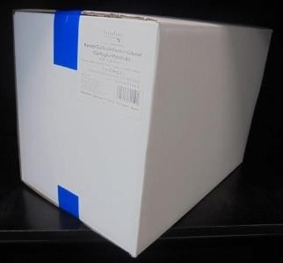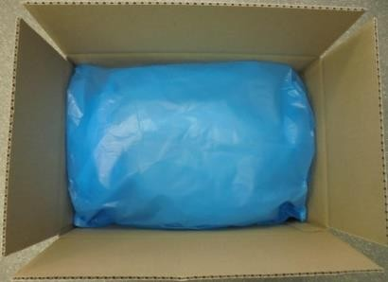  White box Blue PE food grade inner bag  Sealed with blue tape Folded over  Label in the right upper corner on the short side of the box

 | Palletization
Product name | IQF Conventional Coriander 1 mm 1x10kg | IQF Conventional Coriander 1-3 mm 1x10kg | IQF Conventional Coriander 1-6 mm 1x10kg
Product ID | C154IQF001II | C154IQF003II | C154IQF006II
EAN | 54 2500772 173 7 | 54 2500772 168 3 | 54 2500772 169 0
Palletization | Euro (Wood) | Euro (Wood) | Euro (Wood)
# Crt/pallet | 54 | 45 | 42
# Layers x Crt/layer | 6x9 | 5x9 | (4x9)+(1x6)
Pallet height | 166,2 cm | 170,5 cm | 189,8 cm
Carton | White box + Blue PE inner bag | White box + Blue PE inner bag | White box + Blue PE inner bag
# kg net/crt | 10 kg | 10 kg | 10 kg
LxWxH | 380x250x240 mm | 380x250x300 mm | 380x250x360 mm
Tara/crt | 448 g | 468 g | 508 g

Product name | IQF Conventional Coriander 1-12 mm 1x10kg | IQF Conventional  Coriander 1-3 mm with  20% stems 1x10kg | IQF Conventional Coriander stems 1x10kg
Product ID | C154IQF012II | C157IQF203II | C154STE000II
EAN | 54 2500772 425 7 | 54 2500772 167 6 | 54 2500772 371 7
Palletization | Euro (Wood) | Euro (Wood) | Euro (Wood)
# Total crt/pal | 40 | 54 | 45
# Layers x C/layer | (4x9) + (1x4) | 6x9 | 5x9
Pallet height | 209,8 cm | 184,2 cm | 201 cm
Carton | White box + Blue PE inner bag | White box + Blue PE inner bag | White box + Blue PE inner bag
# kg net/carton | 10 kg | 10 kg | 10 kg
LxWxH | 380x250x410 mm | 380x250x270 mm | 380x250x360 mm
Tara/crt | 538 g | 458 g | 508 g

Notes
Pallet height is including pallet.
Maximum pallet height is 210 cm.
Height of the carton can vary in function of the product volume.
Maximum carton height is 430 mm.
Tare weight of the boxes is average weight.
For private label and customized palletization, the 2 last digits of the article code differs. If applicable, conditions as contractually agreed.
For special cut sizes and package, please ask for our conditions and availability.

Product picture and description

1mm  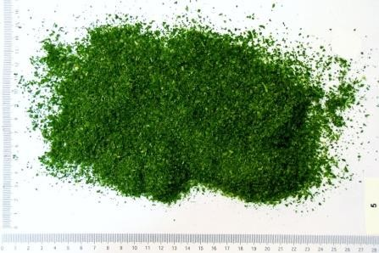  0mm to 1mm : min. 80%  > 1mm : max. 20% | 1-3 mm  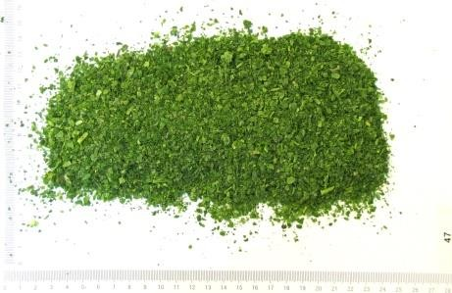  1mm to 3mm : min. 80%  > 3mm : max. 20%
1-6 mm  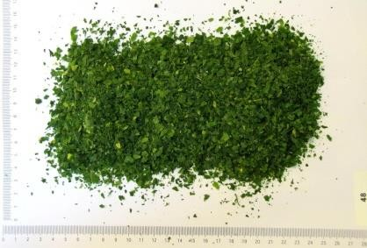  1mm to 6mm : mix. 80%  > 6mm : max. 20% | 1-12 mm  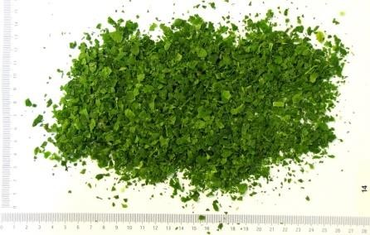  1mm to 12mm : mix. 80%  > 12mm : max. 20%

1-3 mm / 20%  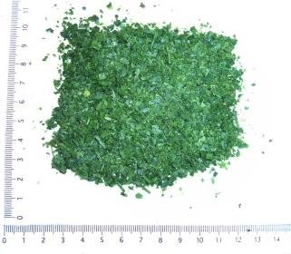  1mm to 3mm : min. 80%  > 3mm : max. 20%  Stems (Weight) : 20% (+/- 10%) | stems  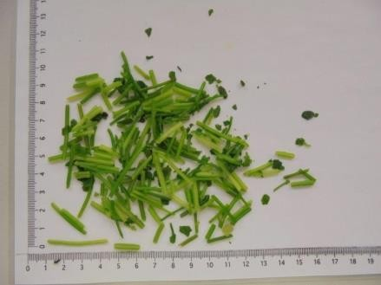  Uncalibrated  0mm to 40mm : min. 80%  > 40 mm : max. 20%  Presence of leaves : max. 15%
Defective parts
Max. 1% (weight) non-toxic vegetable material from the parent plant (flowers,...)
Max. 1% (weight) non-toxic vegetable material not from the parent plant Max. 3% (weight) discoloured pieces
Leaves (1-3mm, 1-6mm, 1-12mm) : max. 5% (weight) stems
Stems (length) > 10 mm: max 5%
1mm: can be slightly block frozen.

Regulatory aspects
- The product is from non-GMO sources and not subject to GMO labelling.
- The product is not ionised.
- Heavy metals: In accordance with EU Regulation 2023/915 (and amendments)
- Pesticides: In accordance with EU Regulation 396/2005 (and amendments)
- Microbiology: In accordance with European Regulation 2073/2005 (and amendments)

APPROVAL

To be completed by the customer
The hereafter named documents are part of this specification.
By signing this document, you agree with the content.
Section Doc. Nr. Doc. Name
Part I EPS.I.00 Supplier Information
Part II EPS.II.01 General product data: Fresh Frozen Herbs CONVENTIONAL
Date:

Name:
Function:

Signature & Company Stamp:

Please send the signed and approved product specification back to Herbafrost nv.
If we do not receive this signed product specification back within 7 working days, we consider the document as approved by your side.

In case of unexpected and exceptional circumstances, Herbafrost will try to meet the customers approved specification in the best possible way, but reserves the right to source products which could have different characteristics (eg. origin, weight, packaging, palletization, …). Herbafrost do guarantee that, whatever the situation may be, the food safety and authenticity of the product will never be compromised.

